**Subhan Bin Yousaf**

**Section B**

**481281**

**FOP Lab Manual 10**

**Task 1 :**

#include<iostream>

#include<vector>

using namespace std;

int main(){

int n=0;

cout<<"enter the number of elements in your vector: ";

cin>>n;

vector<int>v(n);

for(int i=0;i<v.size();i++){

cin>>v[i];

}

vector<int>::iterator it;

for(it=v.begin();it!=v.end();it++){

cout<<*it<<" ";

}

cout<<endl;

v.push_back(5);

for(it=v.begin();it!=v.end();it++){

cout<<*it<<" ";

}

cout<<endl;

v.pop_back();

for(it=v.begin();it!=v.end();it++){

cout<<*it<<" ";

}

return 0;

}

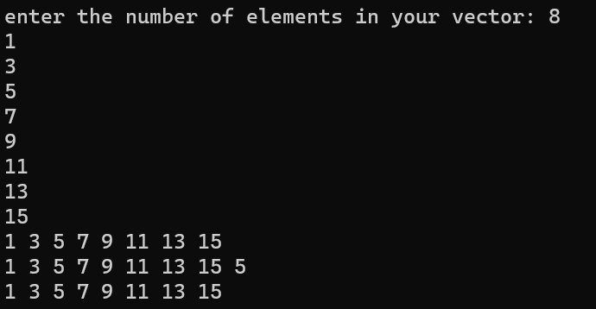

**Task 2 :**

#include<iostream>

#include<algorithm>

#include<vector>

using namespace std;

int main() {

vector<string> names;

vector<int> grades;

int size, grade, median, x = 0, mode;

double mean;

string nam;

cout << "Enter the size of the vector: ";

cin >> size;

cout << "Enter the names in the vector: " << endl;

for (int i = 0; i < size; i++) {

cin >> nam;

names.push_back(nam);

}

cout << "Enter the grades in the vector: " << endl;

for (int i = 0; i < size; i++) {

cout << names[i] << " has grade: ";

cin >> grade;

grades.push_back(grade);

}

cout << "The name/grade pair is as follows: " << endl;

cout << "NAME" << "\t" << " / " << "\t" << "GRADES" << endl;

for (int i = 0; i < size; i++) {

cout << names[i] << "\t" << " / " << "\t" << grades[i] << endl;

}

for (int i = 0; i < size; i++) {

x += grades[i];

}

cout << "The mean of the grades is: ";

mean = static_cast<double>(x) / static_cast<double>(size);

cout << mean << endl;

sort(grades.begin(), grades.end());

median = size / 2;

cout << "The median of the grades is: " << grades[median] << endl;

int maxCount = 0;

for (int i = 0; i < size; i++) {

int count = std::count(grades.begin(), grades.end(), grades[i]);

if (count > maxCount) {

maxCount = count;

mode = grades[i];

}

}

cout << "The mode of the grades is: " << mode << endl;

cout << "The students with grade as their mode are: " << endl;

for (int i = 0; i < size; i++) {

if (grades[i] == mode) {

cout << names[i] << " ";

}

}

cout << endl;

return 0;

}

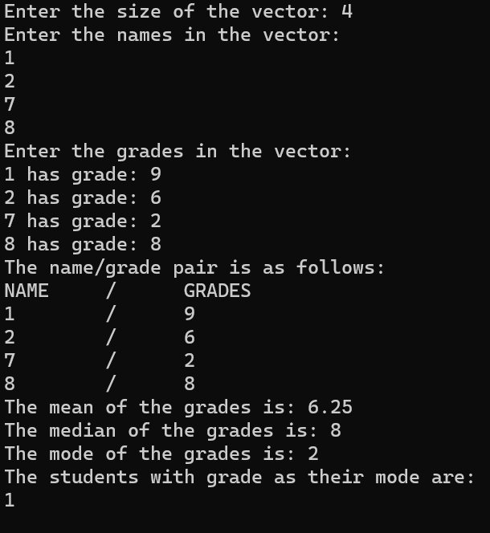

**Task 3 :**

#include <bits/stdc++.h>

using namespace std;

class Triangle {

private:

double side1, side2, side3;

public:

Triangle(double s1, double s2, double s3) : side1(s1), side2(s2), side3(s3) {}

double calculateArea() const {

double s = (side1 + side2 + side3) / 2;

return sqrt(s * (s - side1) * (s - side2) * (s - side3));

}

double calculatePerimeter() const {

return side1 + side2 + side3;

}

void printDetails() const {

cout << "Triangle Details:" <<endl;

cout << "Side 1: " << side1 <<endl;

cout << "Side 2: " << side2 <<endl;

cout << "Side 3: " << side3 << endl;

cout << "Area: " << calculateArea() << " square meters" << endl;

cout << "Perimeter: " << calculatePerimeter() << " meters" << endl;

}

};

int main() {

Triangle myTriangle(3, 4, 5);

myTriangle.printDetails();

return 0;

}

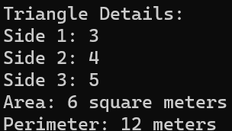

**Task 4 :**

#include <bits/stdc++.h>

using namespace std;

struct Employee {

string name;

double salary;

int hoursWorkedPerDay;

};

void increaseSalary(Employee& emp) {

if (emp.hoursWorkedPerDay > 8) {

emp.salary += (emp.hoursWorkedPerDay - 8) * 10;

}

}

int main() {

const int numEmployees = 10;

Employee employees[numEmployees];

for (int i = 0; i < numEmployees; ++i) {

cout << "Enter name:" << i + 1 << ": ";

getline(cin, employees[i].name);

cout << "Enter salary:" << i + 1 << ": ";

cin >> employees[i].salary;

cout << "Enter hours of work per day:" << i + 1 << ": ";

cin >> employees[i].hoursWorkedPerDay;

cin.ignore();

}

for (int i = 0; i < numEmployees; ++i) {

increaseSalary(employees[i]);

}

cout << "\nEmployee Details after Salary Increase:\n";

for (int i = 0; i < numEmployees; ++i) {

cout << "Name: " << employees[i].name << ", Final Salary: $" << employees[i].salary <<

endl;

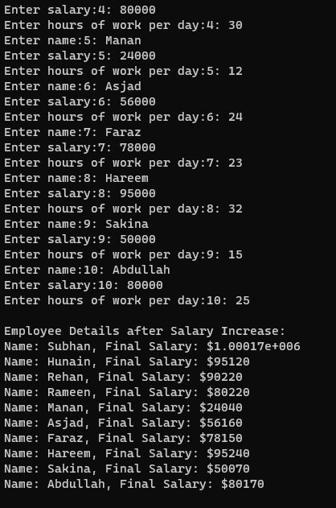 }

return 0;

}